HTML Style

**Table of Content**

* What is HTML Style?
* What are the different types of HTML styles use in HTML document?
* How to provide inline style in HTML?
* How to provide internal style in HTML?
* How to provide External style in HTML?

**What is HTML Style?**

In your HTML document style attribute is used to provide extra features or characteristics like providing different font size, font color, background color and many more features to the HTML element to your web page so that the content which you mention in your HTML Document will look more attractive. We can use style attribute in paragraph tag, form tag, heading tag etc.

**Syntax-** <tagname style=”property: value;”>

**Example-**

<!DOCTYPE html>

<html>

  <head>

    <title>style tag</title>

  </head>

  <body>

    <h1 style="color: rgb(140, 189, 27)">GEEKY4U.com(learn with passion)</h1>

    <h2 style="color: rgb(119, 48, 185)">GEEKY4U.com(learn with passion)</h2>

    <h2 style="color: rgb(214, 52, 165)">GEEKY4U.com(learn with passion)</h2>

  </body>

</html>

**Output-**



**What are the different types of HTML styles use in HTML document?**

In HTML document, Style attributes basically defines that how you can add extra features to your text so that it will looks more attractive also it defines how your document will looks in the browser. Style attribute is having background color, Text color, font, text size, text alignment etc.

**HTML Style with Background color-**

In HTML document if you wish to add Background Color to the existing text then it is important to add Background color style in the HTML start tag.

**Syntax-**

<html start tag style=”background-color: value”> Your text < /html end tag >

**Example-**

<!DOCTYPE html>

<html>

  <head>

    <title>background color</title>

  </head>

  <body>

    <h1 style="background

color: rgba(131, 177, 245, 0.356)">GEEKY4U.com(learn with passion)</h1>

    <h2 style="background-color: rgb(214, 184, 99)">

      GEEKY4U.com(learn with passion)

    </h2>

    <p style="background-color: rgb(175, 29, 131)">

      GEEKY4U.com(learn with passion)

    </p>

  </body>

</html>

**Output-**

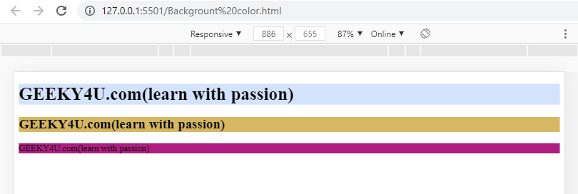

**How we can give Text color to the HTML document?**

In the HTML document, we can give text color to your text by using text color in the HTML style tag. For adding HTML text color, we need to add style tag in the HTML start tag along with the color and its value.

**Syntax-**

<html start tag style=”color: value”> your text </html end tag>

**Example-**

<!DOCTYPE html>

<html>

  <head>

    <title>text color</title>

  </head>

  <body>

    <h2 style="color: rgb(45, 197, 164)">GEEKY4U.com(learn with passion)</h2>

    <p style="color: rgb(99, 9, 72)">GEEKY4U.com(learn with passion)</p>

  </body>

</html>

**Output-**

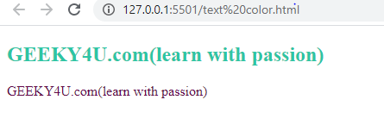

**HTML Fonts in HTML style tag-**

For adding font style to the text HTML consists of one inbuilt attribute called as font family. We can add different font style by using font family with the style tag.

**Syntax-**

<html start tag style=”font-family: value”> your text </html end tag>

**Example-**

<!DOCTYPE html>

<html>

  <head>

    <title> font style</title>

  </head>

  <body>

    <h2 style="font-family: 'Times New Roman', Times, serif">

      GEEKY4U.com(learn with passion)

    </h2>

    <p style="font-family: Arial, Helvetica, sans-serif">

      GEEKY4U.com(learn with passion)

    </p>

  </body>

</html>

**Outlook-**



**HTML style with different Text Size-**

HTML allows to make the text size larger, smaller or according to the user convenience. For adding the different font style we need to mention style tag along with the text size in the HTML start tag.

**Syntax-**

<html start tag style=”font-size : value”> your text </html end tag>

**Example-**

<!DOCTYPE html>

<html>

  <head>

    <title>text size</title>

  </head>

  <body>

    <h1 style="font-size: larger;)">GEEKY4U.com(learn with passion)</h1>

    <h2 style="font-size: smaller">GEEKY4U.com(learn with passion)</h2>

    <p style="font-size: 200%">GEEKY4U.com(learn with passion)</p>

  </body>

</html>

**Output-**



**Text Alignment in HTML style-**

You can give alignment to your text like center, left, right accordingly with the help of text align attribute with the style tag.

**Syntax-**

<html start tag style=”text-align: value”> your text </html end tag>

**Example-**

<!DOCTYPE html>

<html>

  <head>

    <title>text color</title>

  </head>

  <body>

    <h2 style="text-align: center">GEEKY4U.com(learn with passion)</h2>

    <p style="text-align: left">GEEKY4U.com(learn with passion)</p>

    <h2 style="text-align: center">GEEKY4U.com(learn with passion)</h2>

    <p style="text-align: start">GEEKY4U.com(learn with passion)</p>

  </body>

</html>

**Output-**

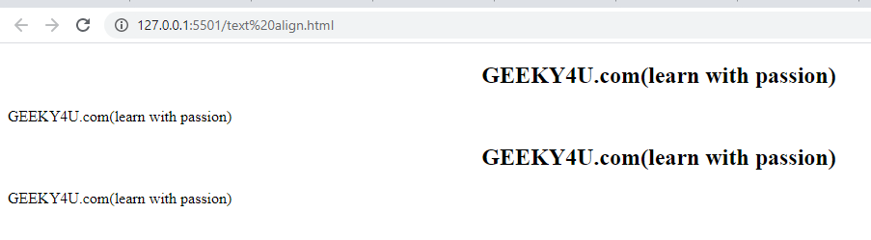

**How to provide inline style in HTML?**

In the inline style, Style attribute is used inside the HTML start tag. It is similar to the basic HTML style tag.

**Example-**

<!DOCTYPE html>

<html>

  <head>

    <title>inline style</title>

  </head>

  <body>

    <h1 style="background-color: rgba(94, 243, 243, 0.356)">

      GEEKY4U.com(learn with passion)

    </h1>

    <h2 style="background-color: rgb(88, 236, 175)">

      GEEKY4U.com(learn with passion)

    </h2>

    <p style="background-color: rgb(193, 226, 46)">

      GEEKY4U.com(learn with passion)

    </p>

  </body>

</html>

**Output-**

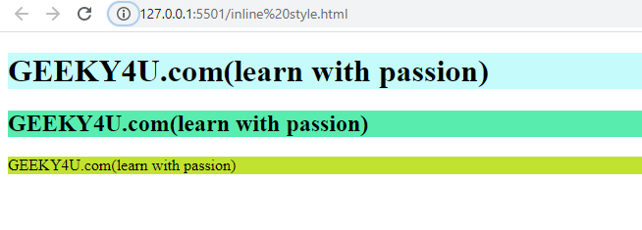

**How to provide internal style in HTML?**

In HTML style tag, Internal style attribute is use for providing HTML style element within the HTML body tag. Whatever the attribute we want to give to the HTML text we need to define all the attribute under the body tag then it will consider as a internal style tag element in HTML.

**Example-**

<!DOCTYPE html>

<html>

  <head>

    <title>internal style</title>

  </head>

  <style>

      h1 {background-color: rgba(202, 71, 93, 0.356)}

     h2 {color: rgb(88, 236, 175)}

     p {background-color: rgb(104, 209, 192)}

  </style>

  <body>

    <h1>

      GEEKY4U.com(learn with passion)

    </h1>

    <h2>

      GEEKY4U.com(learn with passion)

    </h2>

    <p>

      GEEKY4U.com(learn with passion)

    </p>

  </body>

</html>

**Output-**

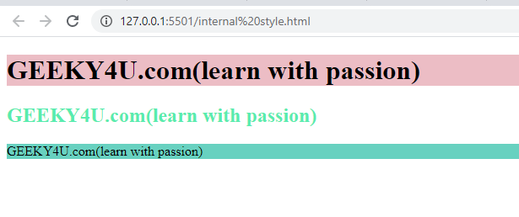

**How to provide External style in HTML?**

External style is use for providing the style attribute through the link which is provided into the HTML head by using external style tag. HTML Style External style attribute is use for providing link into the head tag and by using this attribute HTML page will define style on different pages.

**Example-**

<!DOCTYPE html>

<html>

  <head>

    <title>internal style</title>

    <link rel="stylesheet " href="style.html">

  </head>

  <body>

    <h1>GEEKY4U.com(learn with passion)</h1>

    <h2>GEEKY4U.com(learn with passion)</h2>

    <p>GEEKY4U.com(learn with passion)</p>

  </body>

</html>

**Output-**

